Steps to setup and run the script

1. Install java
2. Copy the jar file into location and open command prompt and execute below line

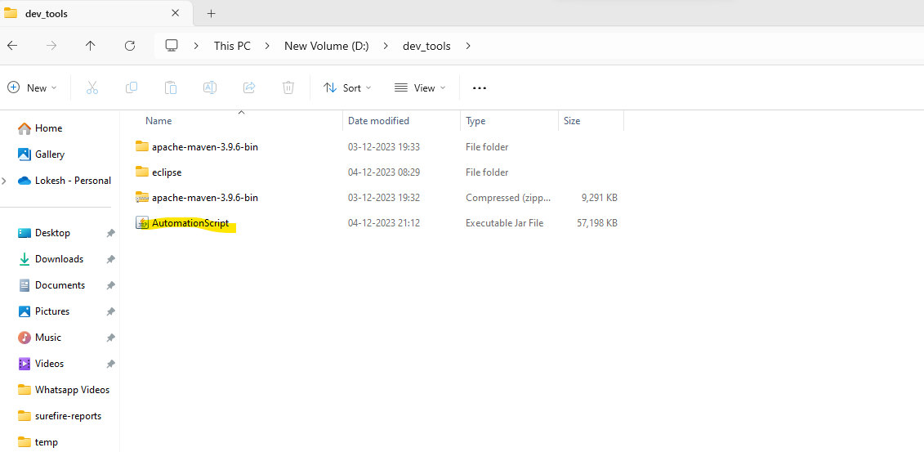

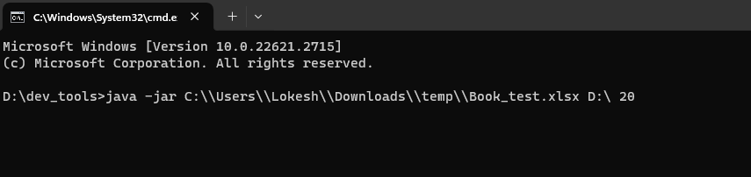

It takes three inputs

1. Source file path - C:\\Users\\Lokesh\\Downloads\\temp\\Book_test.xlsx
2. Destination path where you want to store - D:\
3. How many browser you want to run parallel - 20  
     
   ex:  
   C:\\Users\\Lokesh\\Downloads\\temp\\Book_test.xlsx D:\ 20